PRACTICAL 14: SELENIUM WEB AUTOMATION

1. Aim

To automate website login, product selection, and cart validation using Python Selenium.

2. Test Case Scenario

Test Case ID: TC-14-01

Test Scenario: Login and Product Selection

Test Data: standard_user / secret_sauce

Expected Result: Login successful, product added to cart, and cart opened.

Actual Result: Successfully executed.

Status: Pass

3. Source Code

from selenium import webdriver
from selenium.webdriver.common.by import By

d = webdriver.Chrome()
d.get("https://www.saucedemo.com/")

d.find_element(By.ID, "user-name").send_keys("standard_user")
d.find_element(By.ID, "password").send_keys("secret_sauce")
d.find_element(By.ID, "login-button").click()

d.find_element(By.ID, "add-to-cart-sauce-labs-backpack").click()
d.find_element(By.CLASS_NAME, "shopping_cart_link").click()

print("Test Passed")
d.quit()

4. Output
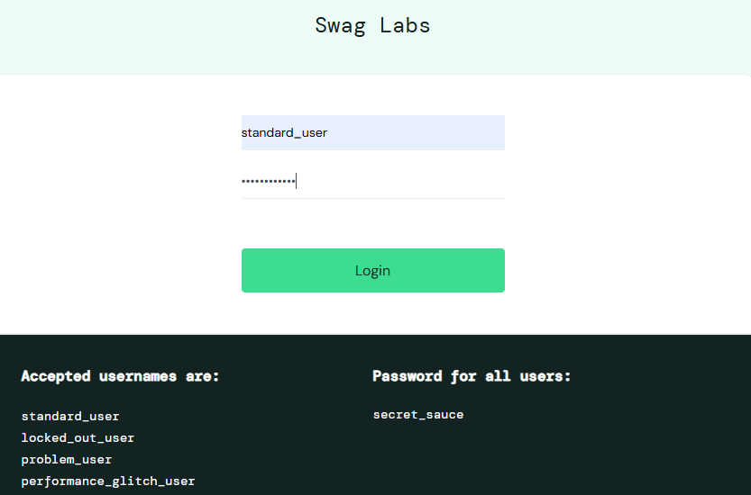

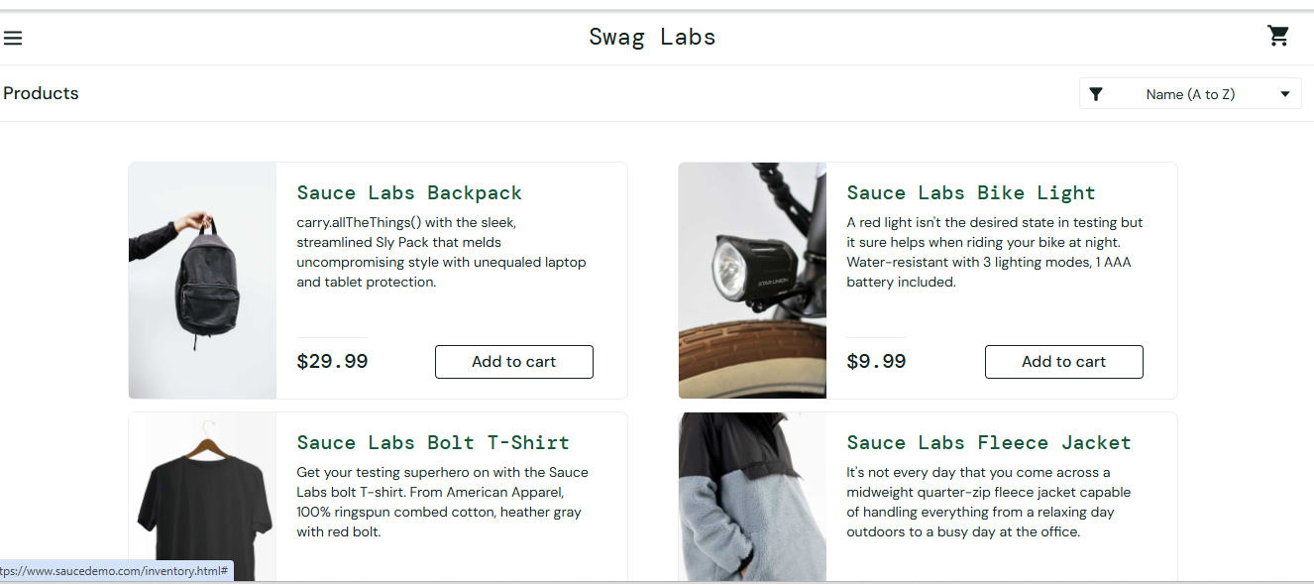

[SCREENSHOT 2:]

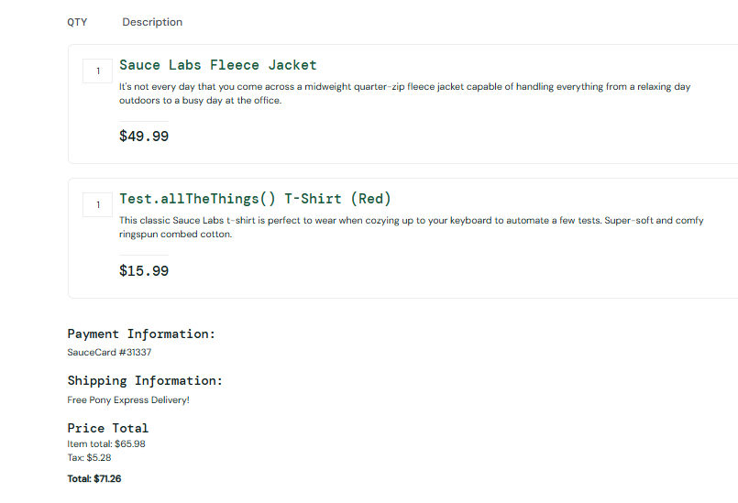

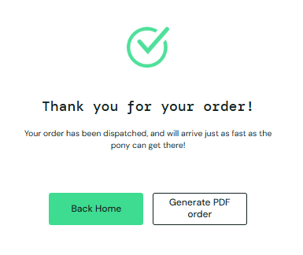
5. Conclusion

Selenium successfully automates login, product selection, and cart navigation.

